IBM APIC Implementation

What is IBM API Connect?
IBM API Connect is an integrated API management offering, where all of the steps in the API lifecycle, and the actions that surround it, are performed within the offering.

The steps of the API lifecycle include creating, running, managing, and securing APIs, as depicted in the following diagram.

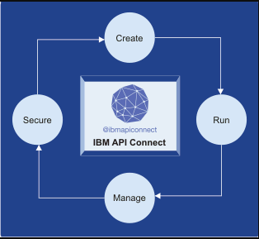
Steps of the API lifecycle
- Create – Develop and write the API definition and implementation, and test the API.
- Run – Package and deploy the API. Ensure that the API is hosted securely on a stable platform.
- Manage – Create and manage self-service portals that expose the API to API consumers. Monitor the set of rules and conditions that govern the API to ensure it is fulfilling its intended purpose, and make adjustments if necessary. Retire and archive the API when appropriate.
- Secure – Incorporate access control, monitoring, and logging to properly secure the API.

There are two tools of IBM APIC creation and management.
- Management – In Management tool we are going to provide the configuration for respective API.
- Portal – In Portal tool, we are going to create the app and subscribe the API to newly created App.

After getting the acess of above tools, we will get below urls.
- Management – https://devapimgt.healthehost.com.apim/
- Portal – https://devapiportal.healthehost.com/activehealth/dv1

Below is IBM API management tool

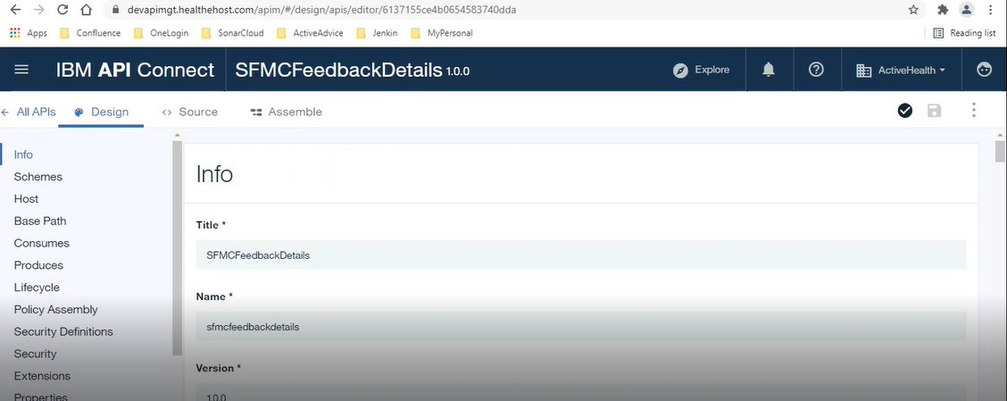
Creating a new API – Need to go to draft from left menu item as shown in below image
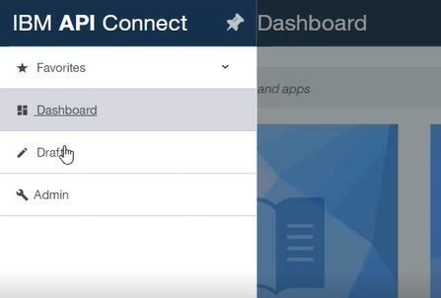
Here we will get two tabs Product and APIs, we need to click on APIs
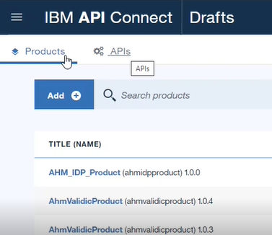

A new API can be created by click on the Add button in above image and selecting New API option from the dropdown menu.

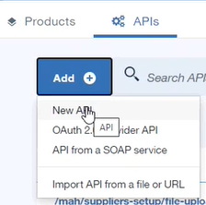

A new popup window will open which expect Title, Name, Base Path, Version as mandatory fields to create new API.

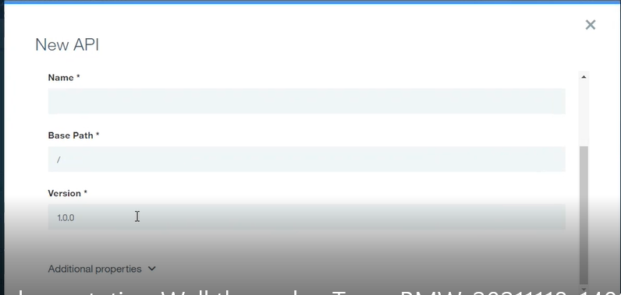

After creating API it will redirect to the newly created API or we can search in main page and navigate to the API.

As we can see in the below image,
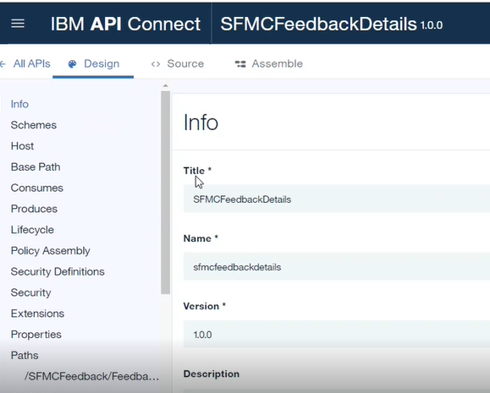
In base path we need to provide /v1 as below image because all the teams are following the same standard.

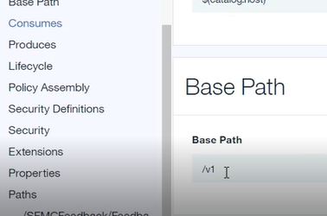
Next section is consumes, where we can select content type like,
- application/json
- application/xml

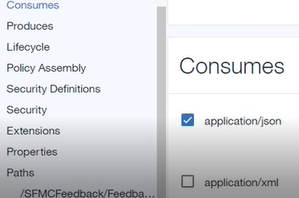

We need to provide security Definitions as per the below image,

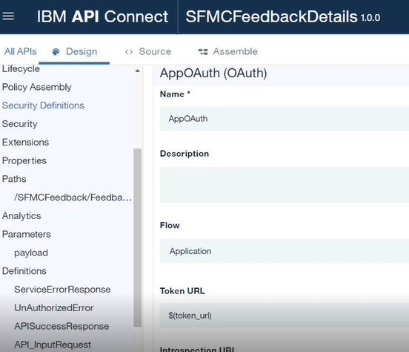
In the abve image, Flow should always be "Application" because we are using token based authentication. After that we can see the below fields for security like Token URL etc.

Scops is also mandatory field to complete the authentication.

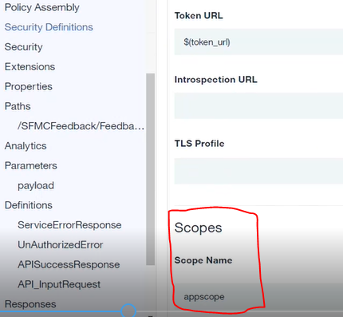
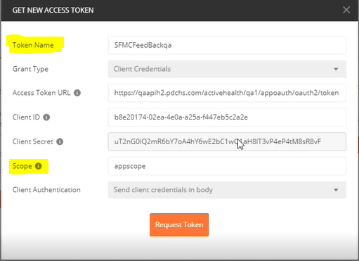

Above fields are mandatory when we try to connect API in postman.

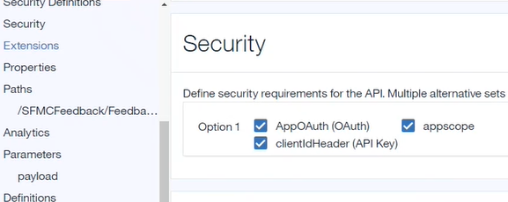
Need to select all check boxes in below image

Next, we need to add properties like token_url and ActiveAdviceRestUrl by clicking on add button in below page,

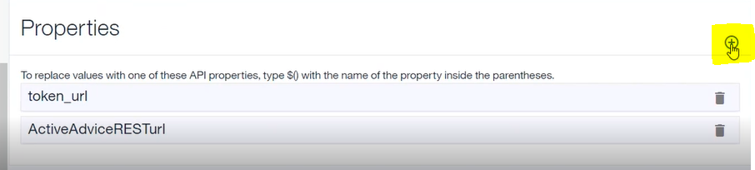
Now we need to click on token_url and add necessary environment url to access the token, shown in the below image

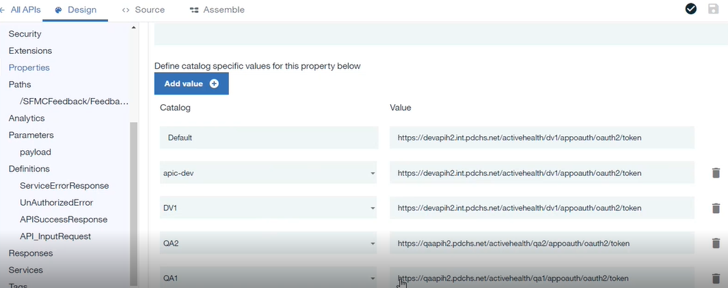
Catalog will have default and specific environment details and it's respective value shows the url to access the token. Above urls we can get from existing APIs or business. Only default catalog is enough initially, later on environment related url can be added.

https://devapih2.int.pdchs.net/activehealth/dv1/appoauth/oauth2/token

A user can get the requested environment url from value field and place it in default value to publish the API endpoint in that environment.

Below is ActiveAdviceRESTurl, this url will be as pe the path of newly created api in AA. This path is our application api path
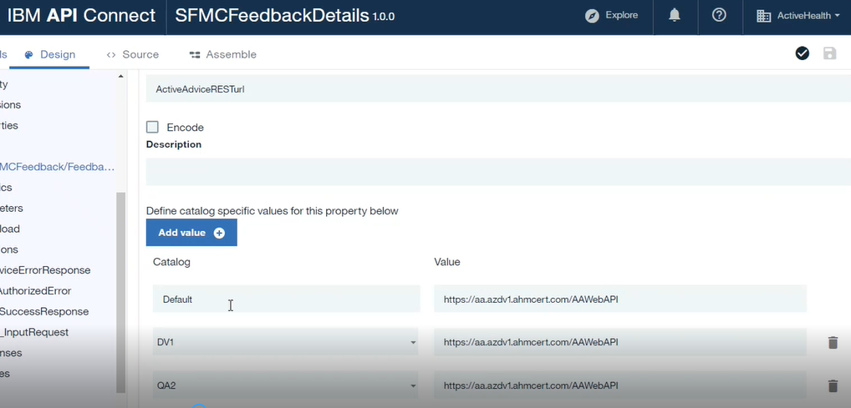
Above path is initial url for application API url and remaining part like controller and action method should be in below field called Paths. We can add it by using + button on the page.

Complete url – Https://aa.azdv1/AAWeb/API/{ControllerName}/{ActionName}
Above image will have the default value of application like Https://aa.azdv1/AAWeb/API/ and below image will have the {ControllerName}/{ActionName}

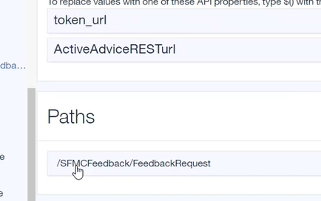

Below image will show the way to define the parameter for respective api

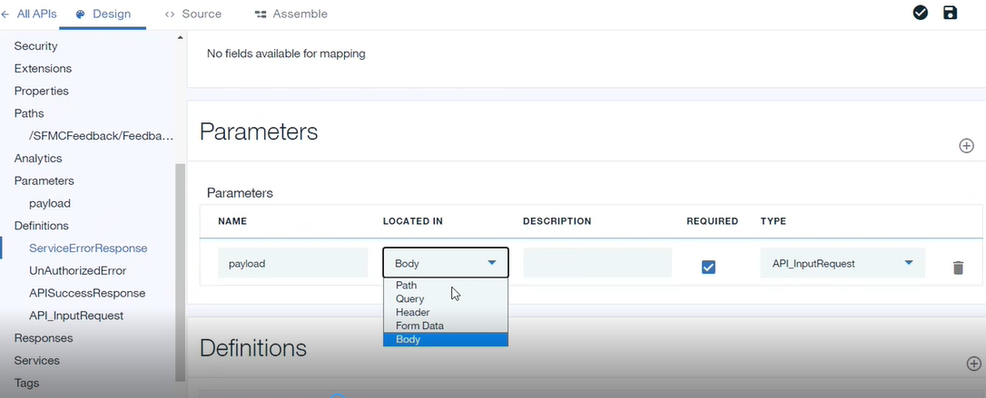
Here we can provide the fileds as per the requirement. We can select the option from above dropdown as per our need.

A user can select the type of parameter as per the requirement, shown below
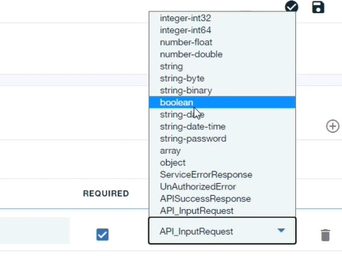
In this dropdown API_InputRequest is user defined type and that we can use to define the type of parameter.

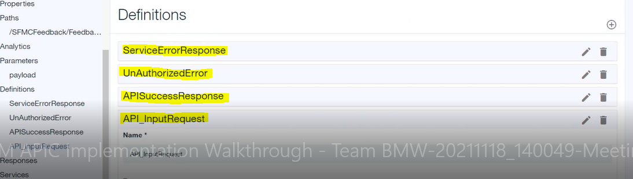
In the above image, we can see the user defined data type. User can add required user-defined data type in Definitions section.

User can create a new definitions type and by clicking on edit option we can give the type of payload for respective variable.

If we are passing input as json then just add new property and edit it. It will open a new windown to provide the schema. As shown in the below image.

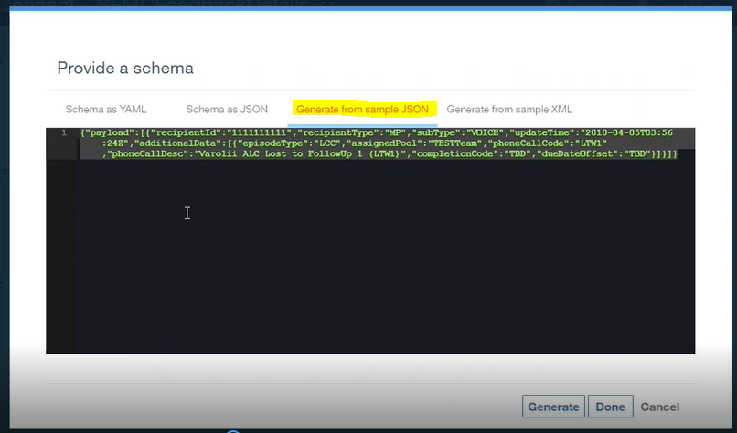
Here we can provide a sample json data which format we want to apply on variable and generate it. It'll create the Schema as JSON by default with default values.
By adding this json it will take care all internal values of that type and then we can select it from the type parameter dropdown of parameter.

For all the errors or success result we have to add respective field in the Definition section as shown in below image

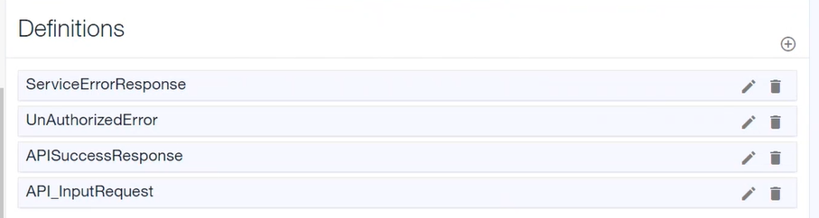
If a user is having multiple specific error then we need to add different error response for each error. We can all only one unhandled error response for unhandled exceptions.

Below image shows the API type like Post, Put, Get etc. This we need to define while creating new API by clicking on Add Operation in Path section. by default it will provide for GET api and we can change it to POST or PUT as per our requirement.

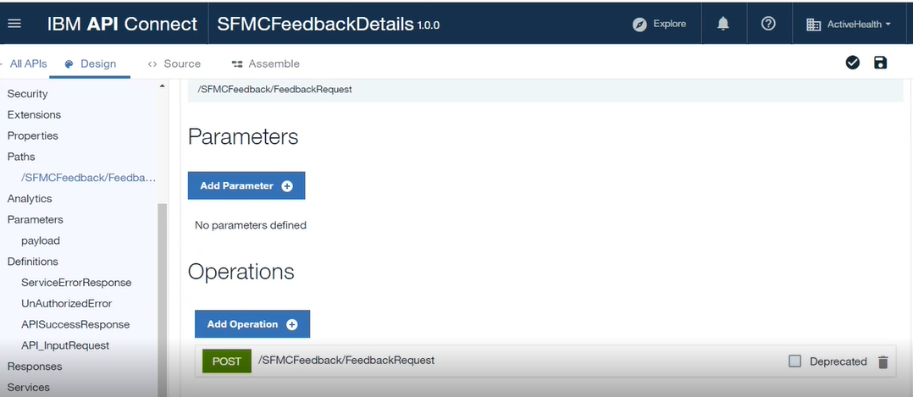
Below responses we can add as per other existing APIs, This responsed we have to add in Path section after defining all the types.

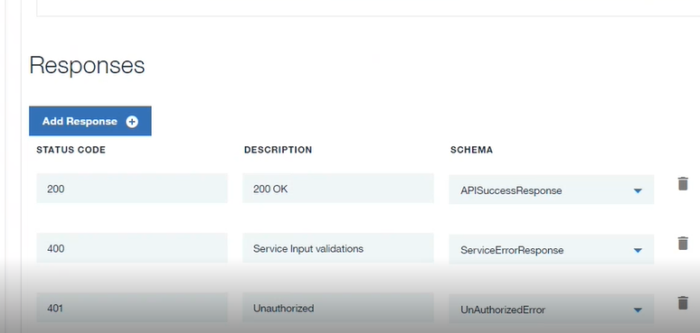

After doing all the changes we need to save all the changes and need to click on validate button as shown in below image

If there is no error the it will display a popup message "Validation Complete" or If there is any error then it will display the error in the same popup box.

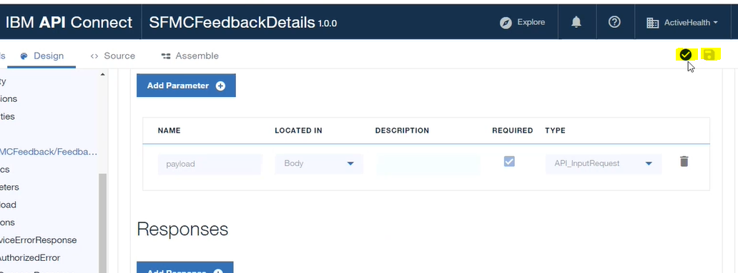

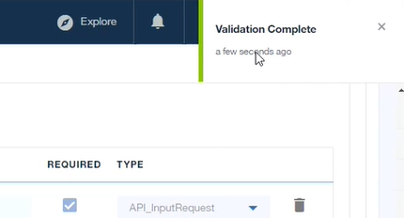
After completing the validation, user can go to Assemble part where API endpoints can be exposed or run based on some logic or switch conditions to dev/prod as shown in below image.

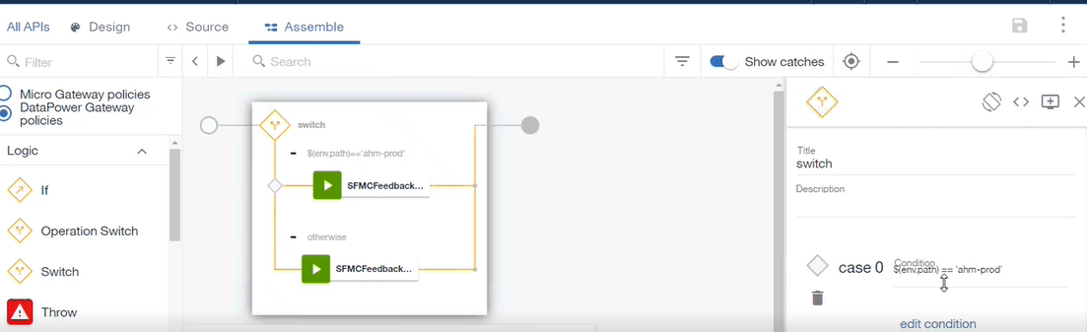

Below image, need to verify the generated url path because the end points will work only when the generated url path is correct.

Here "ActiveAdviceRESTurl" is the property which we have defined in design part of API end point.

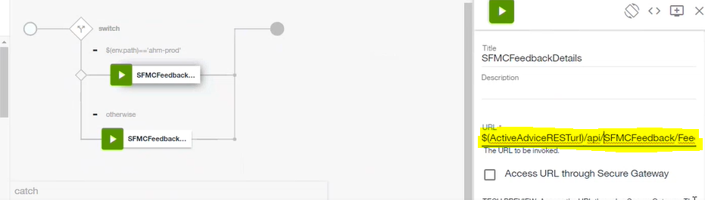
Once everything is validated and successful then user has to click on hamburger menu bar and need to redirect to Drafts option form the menu items.

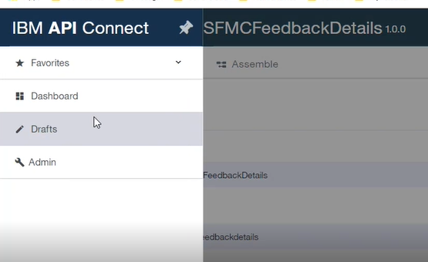
Now API work is done and we need to go to Product tab for deployment process.

Deployment – We need product to keep our API for access purpose. Here we need to add new product as shown in below images.

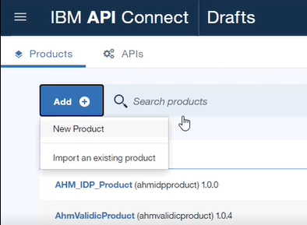
It will open a new popup window and ask for Title, Name, and Version etc.

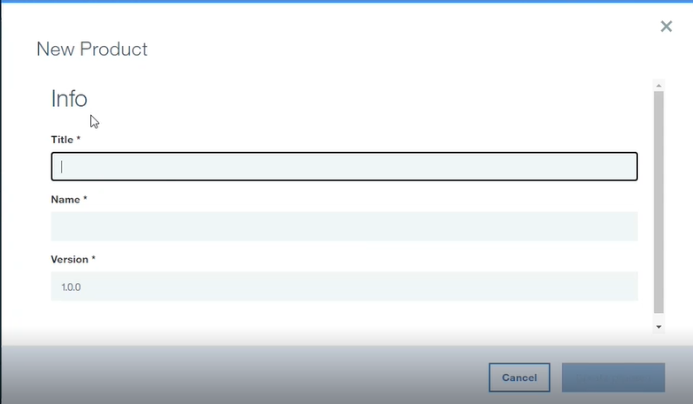
After creating product user is able to see the below screen.

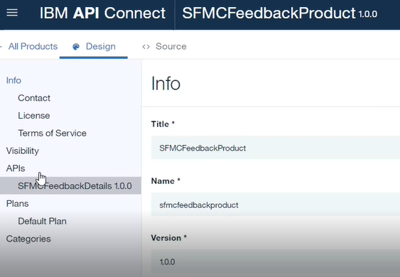
In above screen, user has to click on "APIs" and need to add already implemented API to this product.

Steps are shown in below images

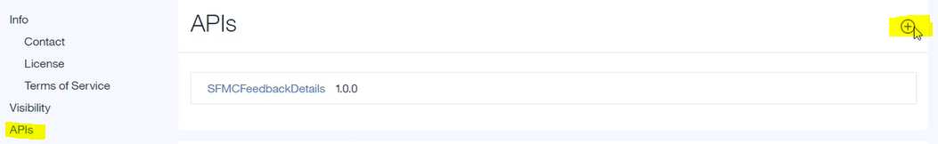
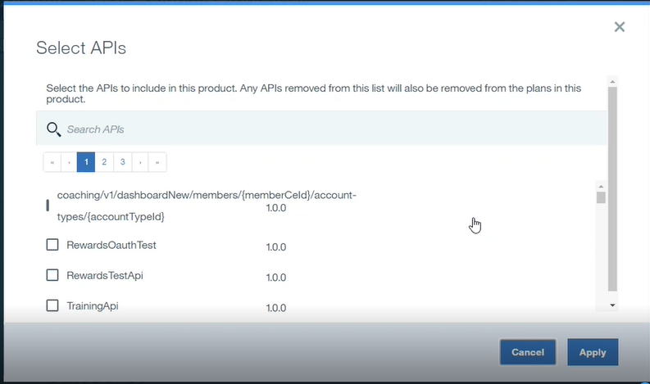
Search the API which user want to add in the product and apply it. As shown in the above image.
These were the steps to create a new product and add our API to this product.
Now a user can publish the newly created product to publish the API. Below are some standards where we can publish the product. Need to get clarity to get the environment.

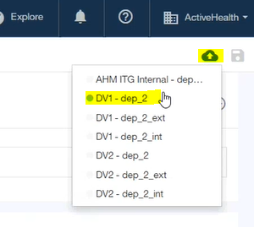
After this need to go to API and Assemble section to select the path in the option as shown in below image.

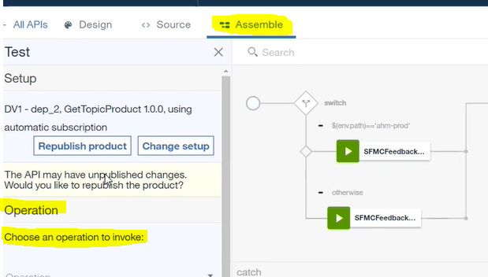
When a user select the opetion the remaining option will be displayed related to credentials and security.

We need to provide client id, client secret id, and other mandatory fields

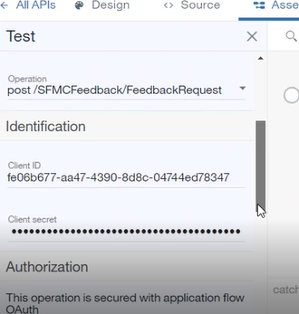
After doing above steps, user has to go to the Portal tool to complete the API accessibility. Below is the Portal tool url.
Https://devapiportal.healthehost.com/activehealth/dv1
After logging in the portal, user will see the below page where we need to click on APIProducts to add the already published api product.

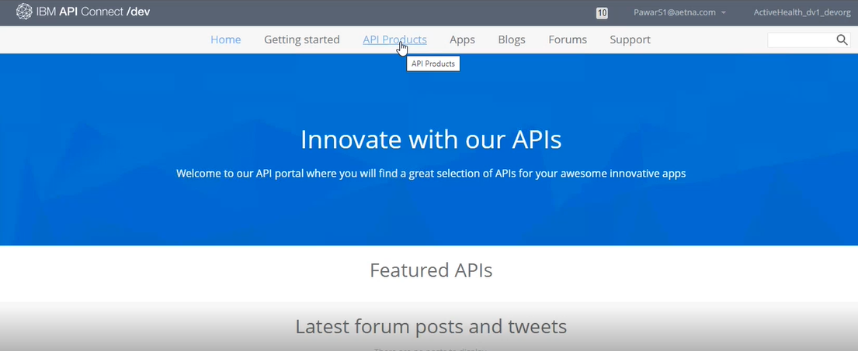
Below is APIProduct screen, On this screen a user can see all the published products and we can search our product in the search box.

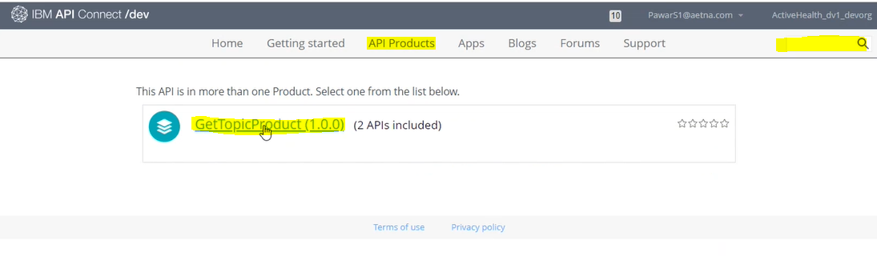
Mostly we can subscribe the existing app instead of creating a new app as shown in below images,

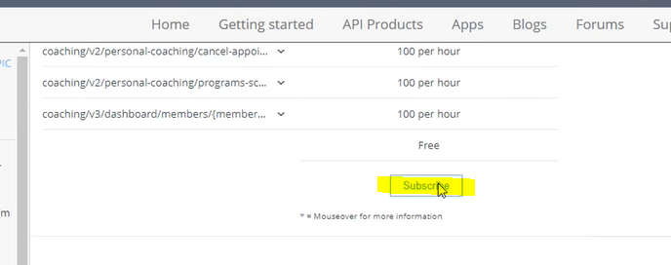

Click on subscribe button as shown in above image and select the already implemented prodcuts from dropdown.

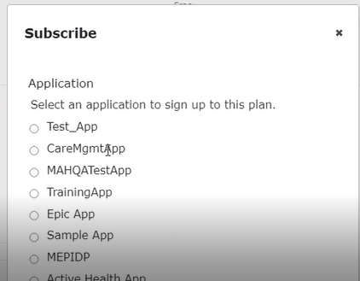
Need to select the app and we can modify the credentials and remaining properties.
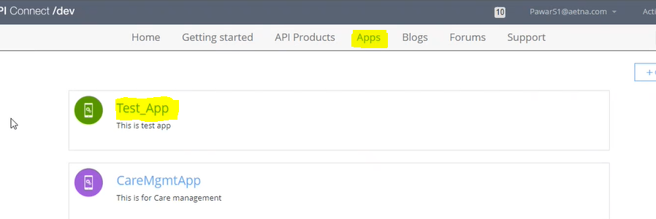
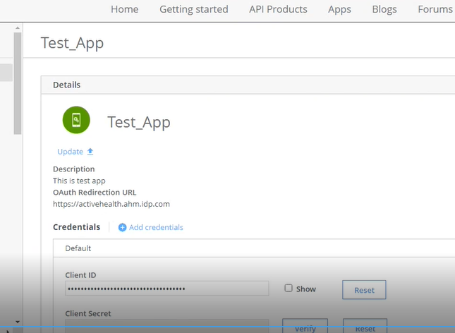

Aove images for existing apps. If a user wants to add new app and credentials then below are the steps.

Create new app
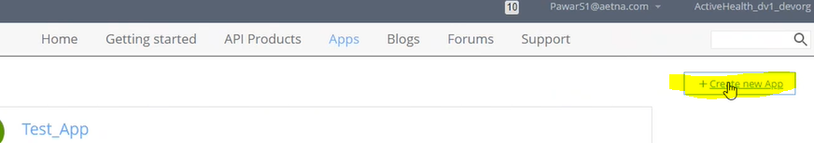
Give the title and required fields then create it.
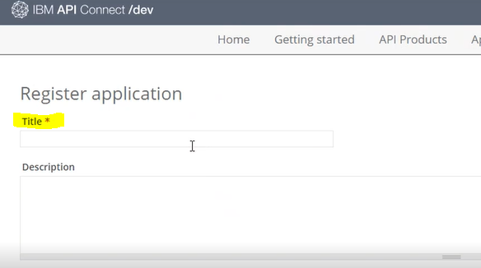
After registring new App, Client secret will automatically be generated and user need to keep it in a text file to access that app. Next page is shown in below image.

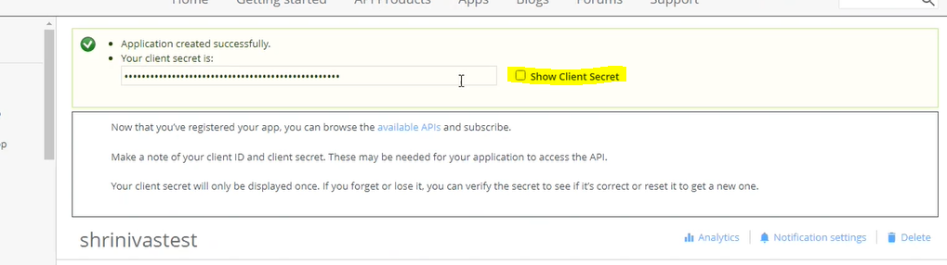
When we scroll down the above page then we can see the client id also and client secret box is empty. We need to copy the client secret and paste it in that empty box as shown in below image.

We need to verify the client secret. This will verify the application secret successfully.

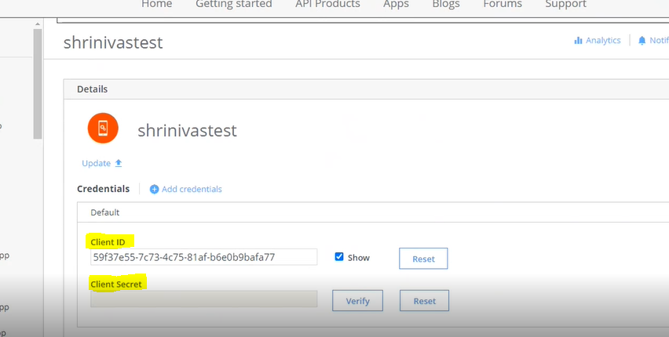
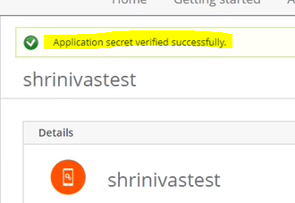
Now user need to subscribe the new App which recently added the credentials. After subscription use has to go to the API from left menu as shown in below image.

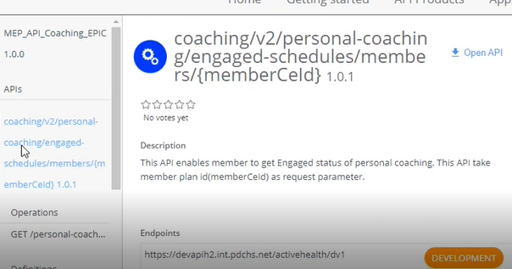
After this we can see the endpoint and mandatory details in right section of API
shown in below image,

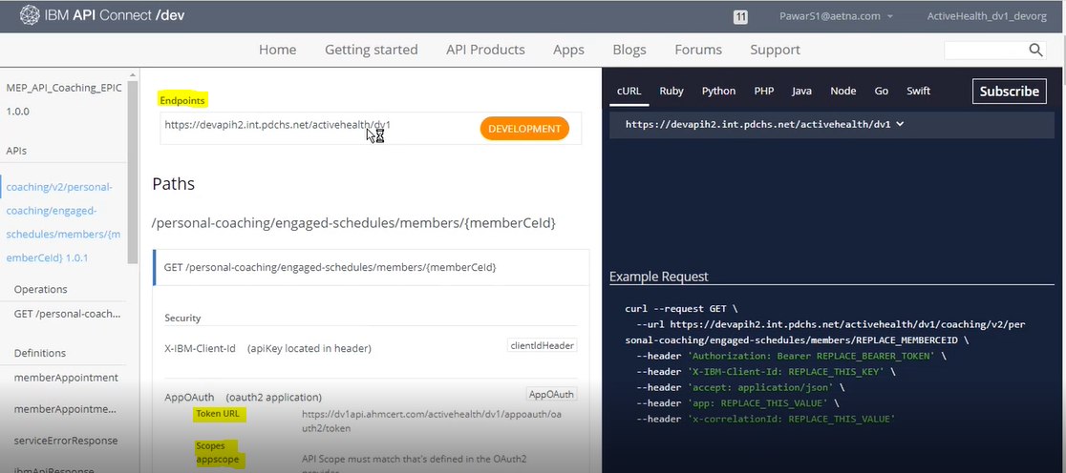
We can provide above endpoints to the perosn who wants to use the API.

Below fields we can provide in postman header as required,

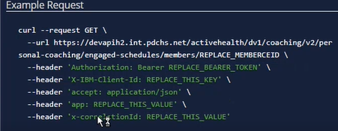
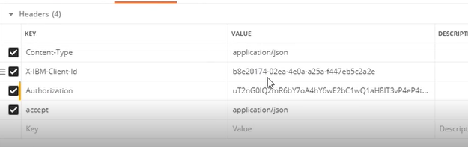
Above is the postman headers

Provde the data and credentials to generate the tokens similar like IPP apis

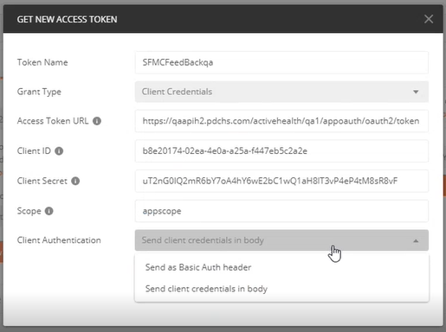

Below are the details to get access for above tools,

- Need to fill the APIC request form. (Team got it in the mail)
- Need to provide Name, email, and NID in the above form
- Subject should be "Request access for IBM API Connect server"
- Mail to: APICAccessRequest@AETNA.com

Versioning – Creating new API should always have version 1.0.0 but when the user story goes in production and any change request comes then we have to update the version manually.

